Outputs – for my sql queries (questions not included. Only Answers pasted for question numbers)

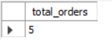
2.
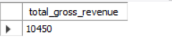

3

4.
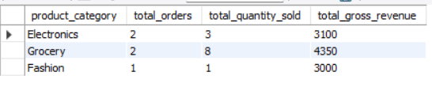

5.
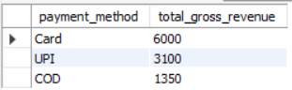

6.
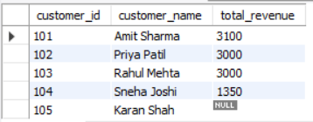
7.
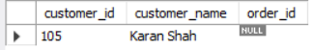

8.

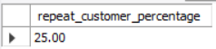

9.
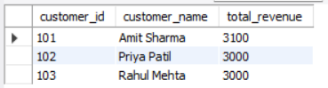

10.
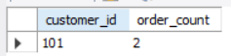

11.
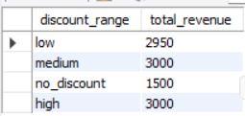

12.
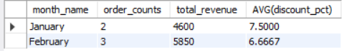

13.
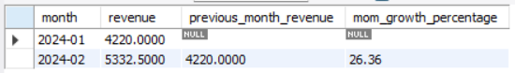

14.
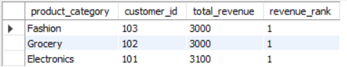

15.
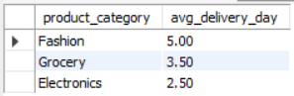

16.
